**Laporan Praktikum**

**Pemrograman Web 1**

**Dosen pengampu : Yati Nurhayati S.Kom., M.Kom**



**Nama : Bayu Imantoro**

**NIM : 20230810089**

**Kelas : TINFC – 2023 – 04**

**Teknik Informatika**

**Fakultas Ilmu Komputer**

**Universitas Kuningan**

PRAKTIKUM

1. <!DOCTYPE html>

<html lang="en">

<head>

<meta charset="UTF-8">

<meta name="viewport" content="width=device-width, initial-scale=1.0">

<title>CSS Embedded</title>

<style>

body {

font-family: Arial, sans-serif;

background-color: #fafa4f;

margin: 0;

padding: 20px;

}

h1 {

color: #a90b0b;

font-style: italic;

letter-spacing: 20px;

text-align: end;

}

p {

color: #0f1ae9;

}

#highlight {

background-color: rgba(0, 195, 255, 0.55);

font-weight: bold;

letter-spacing: -2px;

}

gbawah {

text-transform: lowercase;

text-decoration: underline;

}

</style>

</head>

<body>

<h1>Universitas Kuningan</h1>

<p>Fakultas Ilmu Komputer</p>

<p id="highlight">Teknik Informatika Jenjang S1</p>

<gbawah>JL. Pramuka No. 67, Kuningan</gbawah>

</body>

</html>



1. <!DOCTYPE html>

<html lang="en">

<head>

<meta charset="UTF-8">

<meta name="viewport" content="width=device-width, initial-scale=1.0">

<title>CSS Inline</title>

</head>

<body style="background-color: rgba(217, 214, 214, 0.641);">

<img src="../../modul1/gambar/logoTI.png" style="width: 50px; height: 50px; display: block;

margin: 0 auto; border: 2px solid black; border-radius: 50%;" />

</body>

</html>



1. <!DOCTYPE html>

<html lang="en">

<head>

<meta charset="UTF-8">

<meta name="viewport" content="width=device-width, initial-scale=1.0">

<title>CSS Eksternal</title>

<!-- Link ke file CSS eksternal -->

<link rel="stylesheet" href="stylem3.css">

</head>

<body>

<h1>Universitas Kuningan</h1>

<nav>

<ul class="menu">

<li><a href="#home">Beranda</a></li>

<li>

<a href="#about">Profil</a>

<ul class="dropdown">

<li><a href="#about">Tentang</a></li>

<li><a href="#vmts">Visis Misi</a></li>

</ul>

</li>

<li><a href="#faculty">Fakultas</a></li>

<li><a href="#contact">Kontak</a></li>

</ul>

</nav>

</body>

</html>

CSS

body {

    font-family: Arial, sans-serif;

    margin: 0;

    padding: 20px;

}

nav {

    background-color: rgb(255, 145, 0);

}

.menu {

    list-style-type: none;

    padding: 0;

    margin: 0;

    display: flex;

}

.menu li {

    position: relative;

    margin-right: 20px;

}

.menu a {

    color: white;

    text-decoration: none;

    padding: 15px;

    display: block;

}

.menu a:hover {

    background-color: yellow;

    color: black;

}

/* Dropdown styling */

.dropdown {

    display: none;

    list-style-type: none;

    position: absolute;

    background-color: rgb(255, 145, 0);

    min-width: 160px;

    z-index: 1;

    padding: 0;

    margin: 0;

}

.dropdown li {

    margin: 0;

}

.menu li:hover .dropdown {

    display: block;

}

.dropdown a:hover {

    background-color: yellow;

    color: black;

}

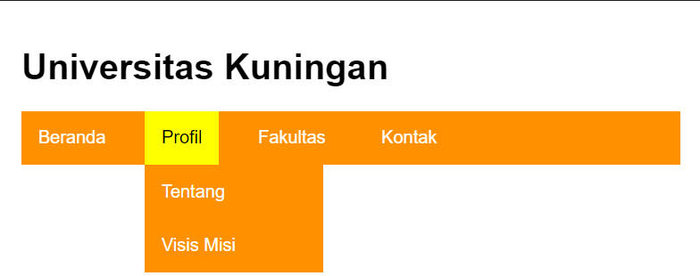

1. <!DOCTYPE html>

<html lang = "id">

<head>

<meta charset = "UTF-8" />

<meta name = "viewport" content = "width=device-width, initial-scale = 1.0" />

<title>CSS Eksternal</title>

<style>

.image-container {

text-align : center;

}

.zoom {

display : inline-block;

border : 2px solid black;

transition : transform 0.3s ease;

}

.zoom:hover {

transform : scale(2.1);

}

</style>

</head>

<body>

<div class = "image-container">

<img src = "../../modul1/gambar/logoTI.png" alt = "Logo TI FKOM UNIKU" class="zoom"

style = "width : 150px; height : 150px; margin-top : 100px;"/>

</div>

</body>

</html>



1. <!DOCTYPE html>

<html lang="id">

<head>

<meta charset = "UTF-8"/>

<meta name = "viewport" content = "width=device-width, initial-scale = 1.0" />

<title>Contoh Teks Bergerak</title>

<style>

.marquee {

width : 100%;

overflow : hidden;

white-space : nowrap;

box-sizing : border-box;

}

.marquee-content {

display : inline-block;

animation : marquee 10s linear infinite;

}

@keyframes marquee {

0% {

transform : translateX(100%);

}

100% {

transform : translateX(-100%);

}

}

</style>

</head>

<body>

<div class = "marquee">

<div class = "marquee-content">

Menjadi Universitas Unggul di Internasional Pada Tahun 2030

</div>

</div>

</body>

</html>



1. <!DOCTYPE html>

<html lang = "id">

<head>

<meta charset = "UTF-8" />

<meta name = "viewport" content = "width=device-width; initial-scale = 1.0">

<title>Layout Website</title>

<link rel = "stylesheet" href = "css/styleKu.css"/>

</head>

<body>

<div class = "container">

<header class = "header">Header</header>

<div class = "main">

<aside class = "sidebar">Sidebar</aside>

<div class = "content">Konten Utama</div>

<aside class = "rightbar">Rightbar</aside>

</div>

<footer class = "footer">Footer</footer>

</div>

</body>

</html>

CSS

body {

    font-family: Arial, sans-serif;

    margin: 0;

    padding: 20px;

}

nav {

    background-color: rgb(255, 155, 0);

}

.menu {

    list-style-type: none;

    padding: 0;

    margin: 0;

    display: flex;

}

.menu li {

    position: relative;

    margin-right: 20px;

}

.menu a {

    color: white;

    text-decoration: none;

    padding: 15px;

    display: block;

}

.menu a:hover {

    background-color: yellow;

    color: black;

}

/*dropsown styling */

.dropdown {

    display: none;

    list-style-type: none;

    position: absolute;

    background-color: rgb(255, 145, 0);

    min-width: 160px;

    z-index: 1;

    padding: 0;

    margin: 0;

}

.dropdown {

    margin: 0;

}

.menu li {

    display: block;

}

.dropdown a:hover {

    background-color: yellow;

    color: black;

}

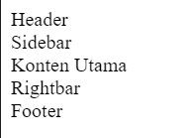

TUGAS

1. Buat from pemesanan dengan tampilan sebagai berikut dengan css

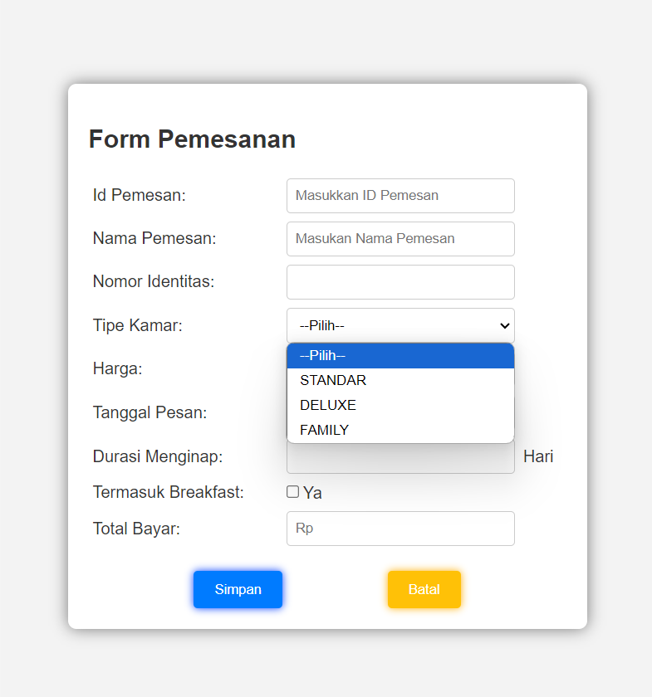

HTML

<!DOCTYPE html>

<html lang="en">

<head>

    <meta charset="UTF-8">

    <meta name="viewport" content="width=device-width, initial-scale=1.0">

    <title>Form Pemesanan</title>

    <link rel="stylesheet" href="styless.css">

</head>

<body>

    <div class="container">

        <h2>Form Pemesanan</h2>

        <form>

            <table>

                <tr>

                    <td>Id Pemesan:</td>

                    <td><input type="number" id="idPemesan" name="idPemesan" placeholder="Masukkan ID Pemesan"></td>

                </tr>

                <tr>

                    <td>Nama Pemesan:</td>

                    <td><input type="text" id="namaPemesan" name="namaPemesan" placeholder="Masukan Nama Pemesan"></td>

                </tr>

                <tr>

                    <td>Nomor Identitas:</td>

                    <td><input type="text" id="nomorIdentitas" name="nomorIdentitas"></td>

                </tr>

                <tr>

                    <td>Tipe Kamar:</td>

                    <td>

                        <select id="tipeKamar" name="tipeKamar">

                            <option value="">--Pilih--</option>

                            <option value="standar">STANDAR</option>

                            <option value="deluxe">DELUXE</option>

                            <option value="family">FAMILY</option>

                        </select>

                    </td>

                </tr>

                <tr>

                    <td>Harga:</td>

                    <td><input type="text" id="harga" name="harga"></td>

                </tr>

                <tr>

                    <td>Tanggal Pesan:</td>

                    <td><input type="date" id="tanggalPesan" name="tanggalPesan"></td>

                </tr>

                <tr>

                    <td>Durasi Menginap:</td>

                    <td><input type="number" id="durasiMenginap" name="durasiMenginap"></td>

                    <td>Hari</td>

                </tr>

                <tr>

                    <td>Termasuk Breakfast:</td>

                    <td><input type="checkbox" id="termasukBreakfast" name="termasukBreakfast">Ya</td>

                </tr>

                <tr>

                    <td>Total Bayar:</td>

                    <td><input type="text" id="totalBayar" name="totalBayar" placeholder="Rp"></td>

                </tr>

            </table>

            <div class="buttons">

                <button type="submit" class="save">Simpan</button>

                <button type="reset" class="cancel">Batal</button>

            </div>

        </form>

    </div>

</body>

</html>

CSS

* {

    box-sizing: border-box;

}

body {

    font-family: Arial, sans-serif;

    background-color: #f3f3f3;

    display: flex;

    justify-content: center;

    align-items: center;

    height: 100vh;

    margin: 0;

}

.container {

    width: 500px;

    padding: 20px;

    background-color: #fff;

    box-shadow: 0px 0px 15px rgba(0, 0, 0, 0.5);

    border-radius: 8px;

}

h2 {

    text-align: left;

    color: #333;

}

form {

    display: flex;

    flex-direction: column;

}

table {

    width: 100%;

    border-collapse: collapse;

    margin-bottom: 20px;

}

td {

    padding: 4px;

    color: #333;

    vertical-align: middle;

}

input[type="text"],

input[type="number"],

input[type="date"],

select {

    padding: 8px;

    border: 1px solid #ccc;

    border-radius: 4px;

    width: 100%;

}

input[type="checkbox"] {

    margin-left: 0;

}

.buttons {

    display: flex;

    justify-content: space-evenly;

}

button {

    padding: 10px 20px;

    border: none;

    border-radius: 4px;

    color: #fff;

    cursor: pointer;

}

button.save {

    background-color: rgb(0, 123, 255);

    box-shadow: 0px 0px 8px rgb(0, 60, 255);

}

button.cancel {

    background-color: #ffc107;

    box-shadow: 0px 0px 8px rgb(255, 174, 0);

}

1. A. Data kamar, berisi : id kamar, gambar ruangan, jenis kamar, harga, fasilitas

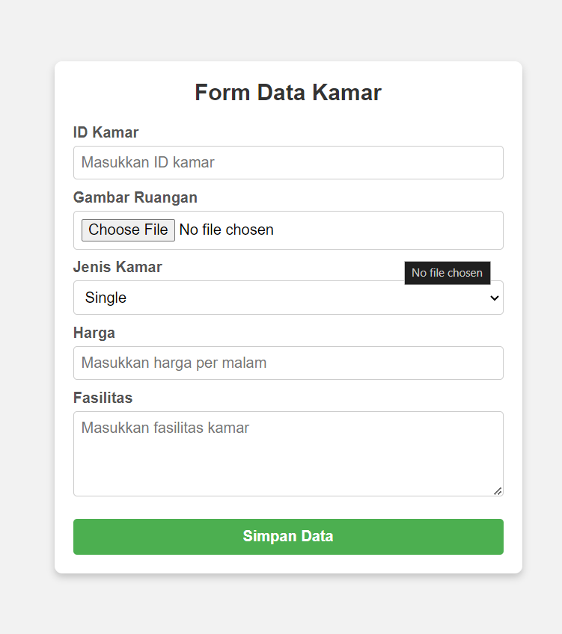

<!DOCTYPE html>

<html lang="en">

<head>

    <meta charset="UTF-8">

    <meta name="viewport" content="width=device-width, initial-scale=1.0">

    <title>Form Data Kamar</title>

    <link rel="stylesheet" href="stylesA.css">

</head>

<body>

    <div class="form-container">

        <h2>Form Data Kamar</h2>

        <form action="#" method="post" enctype="multipart/form-data">

            <label for="id_kamar">ID Kamar</label>

            <input type="text" id="id_kamar" name="id_kamar" placeholder="Masukkan ID kamar" required>

            <label for="gambar_ruangan">Gambar Ruangan</label>

            <input type="file" id="gambar_ruangan" name="gambar_ruangan" accept="image/*" required>

            <label for="jenis_kamar">Jenis Kamar</label>

            <select id="jenis_kamar" name="jenis_kamar" required>

                <option value="single">Single</option>

                <option value="double">Double</option>

                <option value="suite">Suite</option>

            </select>

            <label for="harga">Harga</label>

            <input type="number" id="harga" name="harga" placeholder="Masukkan harga per malam" required>

            <label for="fasilitas">Fasilitas</label>

            <textarea id="fasilitas" name="fasilitas" placeholder="Masukkan fasilitas kamar" rows="4" required></textarea>

            <button type="submit">Simpan Data</button>

        </form>

    </div>

</body>

</html>

CSS

* {

    box-sizing: border-box;

    margin: 0;

    padding: 0;

    font-family: Arial, sans-serif;

}

body {

    display: flex;

    justify-content: center;

    align-items: center;

    min-height: 100vh;

    background-color: #f2f2f2;

}

.form-container {

    width: 100%;

    max-width: 500px;

    background-color: #ffffff;

    padding: 20px;

    border-radius: 8px;

    box-shadow: 0 4px 8px rgba(0, 0, 0, 0.2);

}

.form-container h2 {

    text-align: center;

    color: #333;

    margin-bottom: 20px;

}

label {

    display: block;

    margin-top: 10px;

    color: #555;

    font-weight: bold;

}

input[type="text"],

input[type="file"],

input[type="number"],

select,

textarea {

    width: 100%;

    padding: 8px;

    margin-top: 5px;

    border: 1px solid #ccc;

    border-radius: 4px;

    font-size: 16px;

}

textarea {

    resize: vertical;

}

button[type="submit"] {

    width: 100%;

    padding: 10px;

    margin-top: 20px;

    background-color: #4CAF50;

    border: none;

    color: white;

    font-size: 16px;

    font-weight: bold;

    border-radius: 4px;

    cursor: pointer;

    transition: background-color 0.3s ease;

}

button[type="submit"]:hover {

    background-color: #45a049;

}

B. Fasilitas, berisi: id, nama, fasilitas, harga weekend, harga weekday, kuota, jam buka, jam tutup

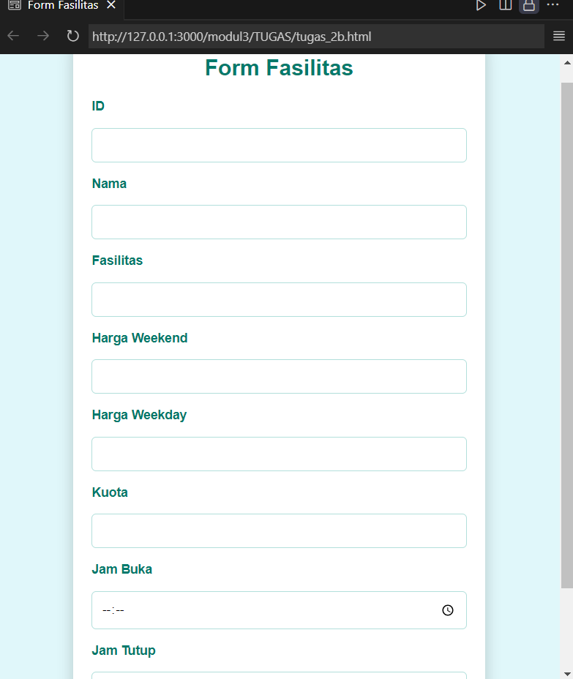

HTML

<!DOCTYPE html>

<html lang="en">

<head>

  <meta charset="UTF-8">

  <meta name="viewport" content="width=device-width, initial-scale=1.0">

  <title>Form Fasilitas</title>

  <link rel="stylesheet" href="stylesB.css">

</head>

<body>

  <div class="container">

    <h2>Form Fasilitas</h2>

    <form action="#" method="POST">

      <label for="id">ID</label>

      <input type="text" id="id" name="id" required>

      <label for="nama">Nama</label>

      <input type="text" id="nama" name="nama" required>

      <label for="fasilitas">Fasilitas</label>

      <input type="text" id="fasilitas" name="fasilitas" required>

      <label for="harga_weekend">Harga Weekend</label>

      <input type="number" id="harga_weekend" name="harga_weekend" required>

      <label for="harga_weekday">Harga Weekday</label>

      <input type="number" id="harga_weekday" name="harga_weekday" required>

      <label for="kuota">Kuota</label>

      <input type="number" id="kuota" name="kuota" required>

      <label for="jam_buka">Jam Buka</label>

      <input type="time" id="jam_buka" name="jam_buka" required>

      <label for="jam_tutup">Jam Tutup</label>

      <input type="time" id="jam_tutup" name="jam_tutup" required>

      <button type="submit">Submit</button>

    </form>

  </div>

</body>

</html>

CSS

* {

    box-sizing: border-box;

    margin: 0;

    padding: 0;

    font-family: Arial, sans-serif;

  }

  body {

    display: flex;

    justify-content: center;

    align-items: center;

    min-height: 100vh;

    background-color: #e0f7fa;

  }

  .container {

    width: 100%;

    max-width: 450px;

    padding: 20px;

    background-color: #ffffff;

    border-radius: 10px;

    box-shadow: 0 8px 16px rgba(0, 0, 0, 0.2);

  }

  h2 {

    text-align: center;

    font-size: 24px;

    margin-bottom: 20px;

    color: #00796b;

  }

  form {

    display: flex;

    flex-direction: column;

    gap: 15px;

  }

  form label {

    font-size: 14px;

    font-weight: 600;

    color: #00796b;

  }

  form input[type="text"],

  form input[type="number"],

  form input[type="time"] {

    width: 100%;

    padding: 10px;

    border: 1px solid #b2dfdb;

    border-radius: 5px;

    outline: none;

    transition: border-color 0.3s;

  }

  form input[type="text"]:focus,

  form input[type="number"]:focus,

  form input[type="time"]:focus {

    border-color: #00796b;

  }

  button {

    padding: 12px;

    background-color: #00796b;

    color: #ffffff;

    border: none;

    border-radius: 5px;

    cursor: pointer;

    font-size: 16px;

    font-weight: bold;

    transition: background-color 0.3s;

  }

  button:hover {

    background-color: #004d40;

  }

1. Buat desain web dengan tampilan sebagai berikut menggunakan css:

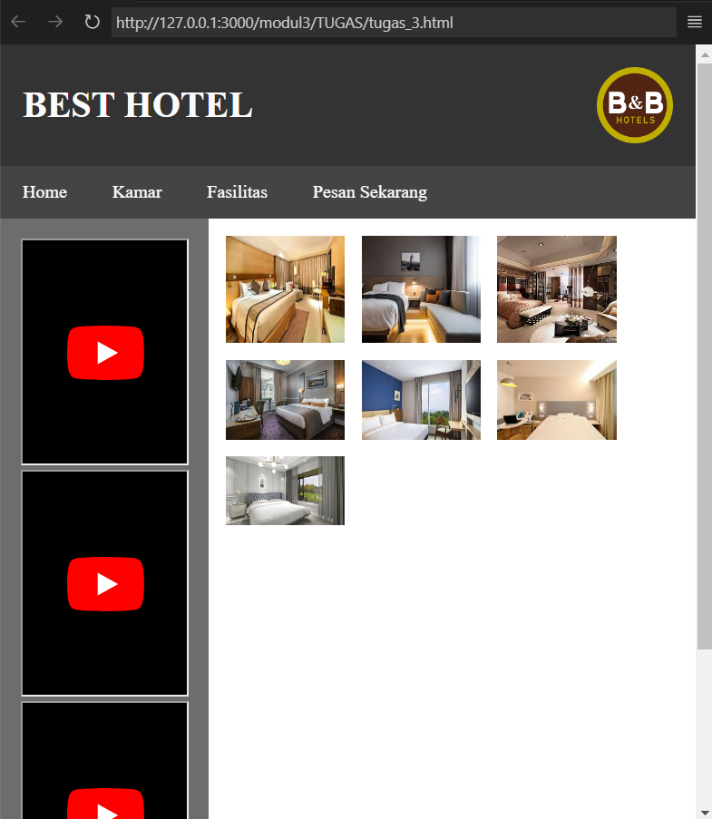

<!DOCTYPE html>

<html lang="en">

<head>

    <meta charset="UTF-8">

    <meta name="viewport" content="width=device-width, initial-scale=1.0">

    <title>Best Hotel</title>

    <link rel="stylesheet" href="style3.css">

</head>

<body>

    <header>

        <h1>BEST HOTEL</h1>

        <img class="logo" src="https://www.pngall.com/wp-content/uploads/5/Hotel-PNG-Image-HD.png" alt="Hotel Logo">

    </header>

    <nav>

        <ul>

            <li><a href="#">Home</a></li>

            <li><a href="#">Kamar</a></li>

            <li class="dropdown">

                <input type="checkbox" id="fasilitas-checkbox" class="menu-checkbox">

                <label for="fasilitas-checkbox">Fasilitas</label>

                <ul class="submenu">

                    <li><a href="#">Petualangan Alam</a></li>

                    <li class="dropdown">

                        <input type="checkbox" id="kolam-checkbox" class="menu-checkbox">

                        <label for="kolam-checkbox">Kolam Renang</label>

                        <ul class="submenu">

                            <li><a href="#">Sumber Air Panas</a></li>

                            <li class="dropdown">

                                <input type="checkbox" id="anak-dewasa-checkbox" class="menu-checkbox">

                                <label for="anak-dewasa-checkbox">Kolam Anak & Dewasa</label>

                                <ul class="submenu">

                                    <li><a href="#">Reguler</a></li>

                                    <li><a href="#">Premium</a></li>

                                </ul>

                            </li>

                        </ul>

                    </li>

                    <li><a href="#">Pusat Kebugaran</a></li>

                    <li><a href="#">Ruang Rapat</a></li>

                </ul>

            </li>

            <li><a href="#">Pesan Sekarang</a></li>

        </ul>

    </nav>

    <div class="container">

        <aside class="leftbar">

            <iframe width="100%" height="200" src="https://www.youtube.com/embed/example_video"></iframe>

            <iframe width="100%" height="200" src="https://www.youtube.com/embed/example_video"></iframe>

            <iframe width="100%" height="200" src="https://www.youtube.com/embed/example_video"></iframe>

        </aside>

        <main>

            <div class="content">

                <img src="https://th.bing.com/th/id/OIP.2sZkdAns7xEbaX3zfYOYpQHaEK?w=329&h=185&c=7&r=0&o=5&dpr=1.3&pid=1.7" alt="Room 1">

                <img src="https://th.bing.com/th/id/OIP.QMpdkPyGEbqeljQylf2-wwHaE8?w=275&h=184&c=7&r=0&o=5&dpr=1.3&pid=1.7" alt="Room 2">

                <img src="https://th.bing.com/th/id/OIP.9tUwxbex8d4AK0054RHl5gHaE7?w=199&h=180&c=7&r=0&o=5&dpr=1.3&pid=1.7" alt="Room 3">

                <img src="https://cdn.idntimes.com/content-images/post/20200918/hotel-cassidys-21-heritage-room-double-88cd2f4a6f984d1dbb6a726cea520893.jpg" alt="Room 4">

                <img src="https://th.bing.com/th/id/OIP.XwW22cF6M9hgY0IvnrhFqQHaEK?w=324&h=182&c=7&r=0&o=5&dpr=1.3&pid=1.7" alt="Room 5">

                <img src="https://th.bing.com/th/id/OIF.pNGy0x0VIQpjHO0cuS35WQ?w=287&h=187&c=7&r=0&o=5&dpr=1.3&pid=1.7" alt="Room 6">

                <img src="https://th.bing.com/th/id/OIF.SenrFsQn2HqO68ysavGHMA?w=312&h=180&c=7&r=0&o=5&dpr=1.3&pid=1.7" alt="Room 7">

            </div>

        </main>

    </div>

    <footer>

        <p>&copy; 2024 Queen Best Hotel</p>

    </footer>

CSS

        /* basic reset */

        * {

            margin: 0;

            padding: 0;

            box-sizing: border-box;

        }

        /* styling header */

        header {

            background-color: #333;

            color: #fbfbfb;

            display: flex;

            justify-content: space-between;

            align-items: center;

            padding: 20px;

        }

        /* styling logo */

        header .logo {

            width: 67px;

            height: auto;

        }

        /* styling navigation */

        nav {

            background-color: #444;

        }

        nav ul {

            list-style-type: none;

            padding: 0;

            display: flex;

            position: relative;

        }

        /* Hapus garis bawah dan ubah warna font */

        nav ul li a, nav ul li label {

            color: #fff;

            text-decoration: none;

            padding: 14px 20px;

            display: block;

            cursor: pointer;

        }

        /* Hide checkboxes */

        .menu-checkbox {

            display: none;

        }

        /* Styling for Dropdown Menu */

        nav ul .submenu {

            display: none;

            position: absolute;

            background-color: #555;

            list-style-type: none;

            padding: 0;

            margin: 0;

            top: 100%;

            left: 1;

            min-width: 200px;

        }

        /* Show submenu when the corresponding checkbox is checked */

        .menu-checkbox:checked + label + .submenu {

            display: block;

        }

        /* Styling for nested submenu */

        nav ul .submenu .submenu {

            top: 0;

            left: 100%;

        }

        /* Styling for submenu items */

        nav ul .submenu li {

            position: relative;

        }

        nav ul .submenu li a {

            padding: 10px;

            color: #fff;

            background-color: #555;

        }

        /* Styling main container */

        .container {

            display: flex;

        }

        /* Styling left sidebar */

        .leftbar {

            width: 30%;

            background-color: #6d6d6d;

            padding: 18px;

        }

        /* Styling main content */

        main {

            width: 70%;

            padding: 15px;

        }

        .content {

            display: flex;

            flex-wrap: wrap;

            gap: 15px;

        }

        .content img {

            width: calc(30% - 15px);

            height: auto;

        }

        /* Styling footer */

        footer {

            background-color: #333;

            color: #ffffff;

            text-align: center;

            padding: 15px 0;

            margin-top: 20px;

        }